Uniform & Clothing Required
for Manor House Classes
(Willow, Elm & Limetree)

Item | Price per item
Red Sweatshirt (minimum of 2 required) | £16.50
Navy Polo Shirt | £14.00
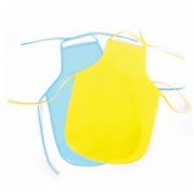  Navy Jogging Bottoms for Winter | £14.50
Navy Shorts for Summer | £13.00
Navy Cookery Apron | £7.50
Waterproof reversible jacket | £26.00
Art Apron | £7.50
Blue Shoe Bag | £4.50
Red Work Pocket | £6.50
Navy Hat | £6.50
T-shirt for P.E. | £7.00
Shorts for P.E. | £5.50

All of the above items can be purchased from Reception

- Parents are asked to provide two complete changes of clothing.

- Please ensure ALL items are labelled and packed in the blue shoe bags.

- Shoes must either be Velcro or buckle fastening – no laces!

- Children will be changing for P.E. after the Easter holidays and are required to wear navy shorts / cycling shorts, white t-shirt, ankle socks and plimsolls.
- If nappies are being used please provide a minimum of 5 for each full day’s session.

