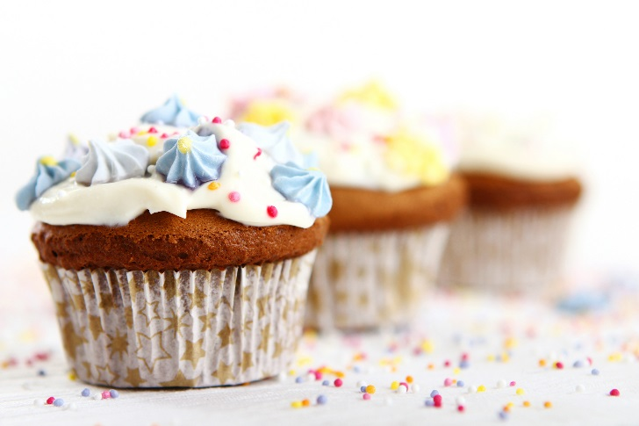

**Clowns Cake Sale**

**Newsflash!**

Thank you to all the bakers and customers we had supporting us at our first charity cake sale on Wednesday 19th October 2016, for ‘Rays of Sunshine.’

We had an array of delightful treats from cupcakes, to jam tarts, a bounty of brownies, Russian cheesecake and many more exquisite confectionaries.

We managed to raise a tremendous

**£610.00!!**

Thank you so much for your ongoing help and support!