Rays of Sunshine wishes sponsored by Clown’s Nursery
January 2017
Sham, age 11, from Northfield, Birmingham
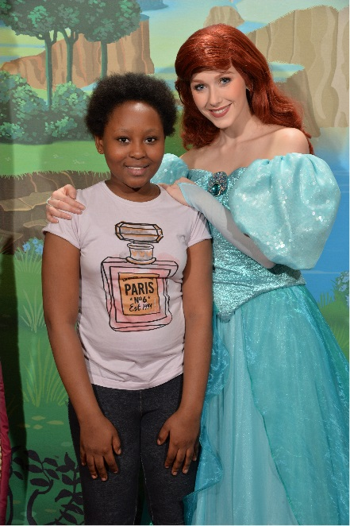
Sham is currently living with Acute Myeloid Leukaemia and is being treated at Birmingham Children's Hospital. Her greatest wish was to go to Disneyland Paris.
11-year-old Sham, from Birmingham, is currently living with Acute Myeloid Leukaemia, a cancer that affects the blood cells, resulting in her needing Chemotherapy treatment. Despite what she has been through, Sham has remained brave and positive throughout. Her greatest wish was to go to Disneyland Paris.
With your help, Rays of Sunshine was able to organise for Sham and her family to travel to Paris, where they spent an exciting couple of days exploring the magical theme park. The trip gave Sham the opportunity to forget about her illness for a short while and creative some incredible memories.
After her wish, Sham commented: “I want to thank Rays of Sunshine for granting my wish to go Disneyland Paris. I really did enjoy it and it was a lot of fun. The food in Disneyland Paris were very yummy and wonderful so thank you for that too.”
Sofie, age 9, from Middlesbrough
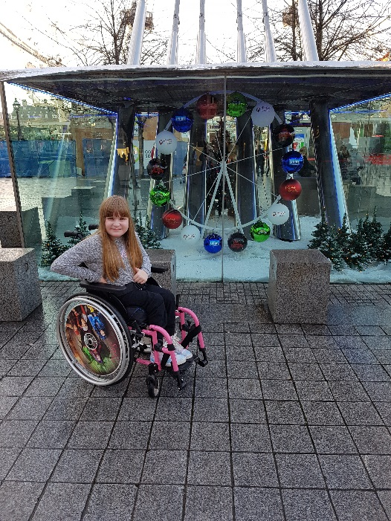
Sofie is currently living with Spina Bifida and is being treated at the Royal Victoria Infirmary. Her greatest wish was to go to Harry Potter World.
Sofie, from Middlesbrough, is currently living with Spina Bifida, a rare condition that affects the spine, meaning she is required to wear a back brace for 20 hours a day and will need surgery in the near future. She has to take regular trips to hospital for check-ups and relies on the use of a wheelchair. Despite her illness, Sofie is a very bright and positive child. She is a big fan of Harry Potter and this was the inspiration for her greatest wish.
With your help, Rays of Sunshine was able to organise for Sofie and her family to travel to London for two days, where she was able to explore the sights fulfilling her greatest ambition to visit the Harry Potter Studios. The trip gave Sofie the chance to feel truly special for the day.

Tymmi, age 7, from Basingstoke, Hampshire
Tymmi is currently living with Acute Myeloid Leukaemia and is being treated at Bristol Royal Hospital for Children. His greatest wish was the meet the Chelsea team.
Seven-year-old Tymmi is currently living with Acute Myeloid Leukaemia, a cancer of the blood cells. Due to his condition, Tymmi has been required to have Chemotherapy as well as a Bone Marrow Transplant. He is a huge fan of Chelsea FC and this was the inspiration for his greatest wish.
With your help, Rays of Sunshine was able to organise for Tymmi and his family to travel to Cobham, where he was able to meet his idols and enjoy the honour of watching them train. Before heading home from his exciting day Tymmi’s and his family were treated to a family meal.

The wish gave Tymmi and his family the chance to create some unforgettable memories and to feel like a true VIP for the day.

