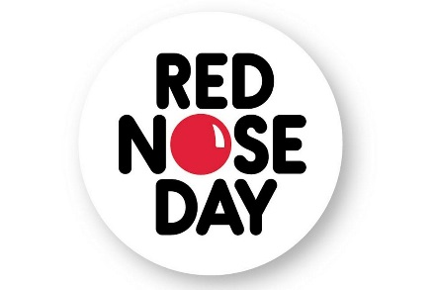
Cake Sale

Thank you to all of you that bought our delicious treats at our Cake Sale on Thursday 23rd March 2017. We do hope you enjoyed them. We were delighted you all dressed up on Friday to celebrate Red Nose Day.

We are overjoyed to tell you that over the two days we made a huge
£832.00!
This is an amazing achievement and we could not have done it without your kindness and generosity.

Thank you!

Tracy Landy Sonia Sliney
Manager/ Proprietor Special Events Coordinator

